# Adding a User using the Program

## To Start - Background

* This document will show you how you can add a user and their access code to the database.
* Team 1 has an admin user. You must login as that admin user in order to access hunt functionality.

### Steps

1. Run the program. You should be taken to this screen:

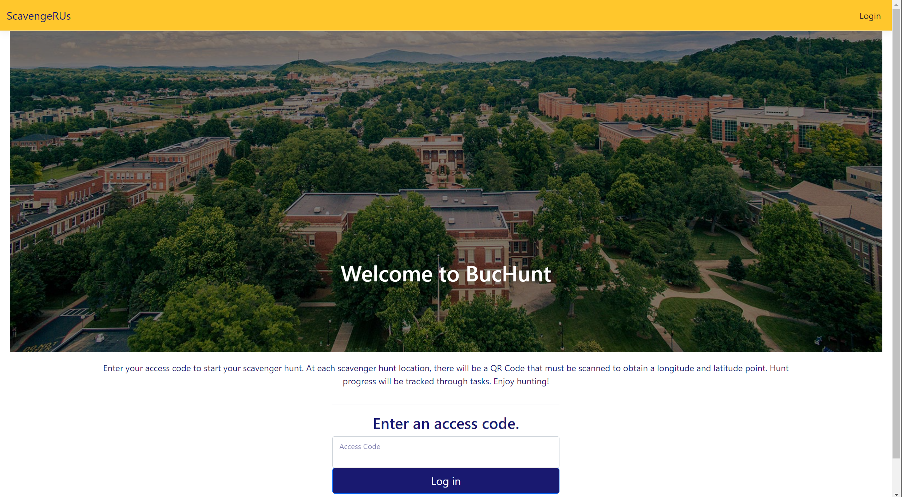

1. You probably start off logged in as a test user. On the top-right of the screen, click “Log Out”.
2. Then click “Login” after you’ve logged out. You should be taken to this screen:

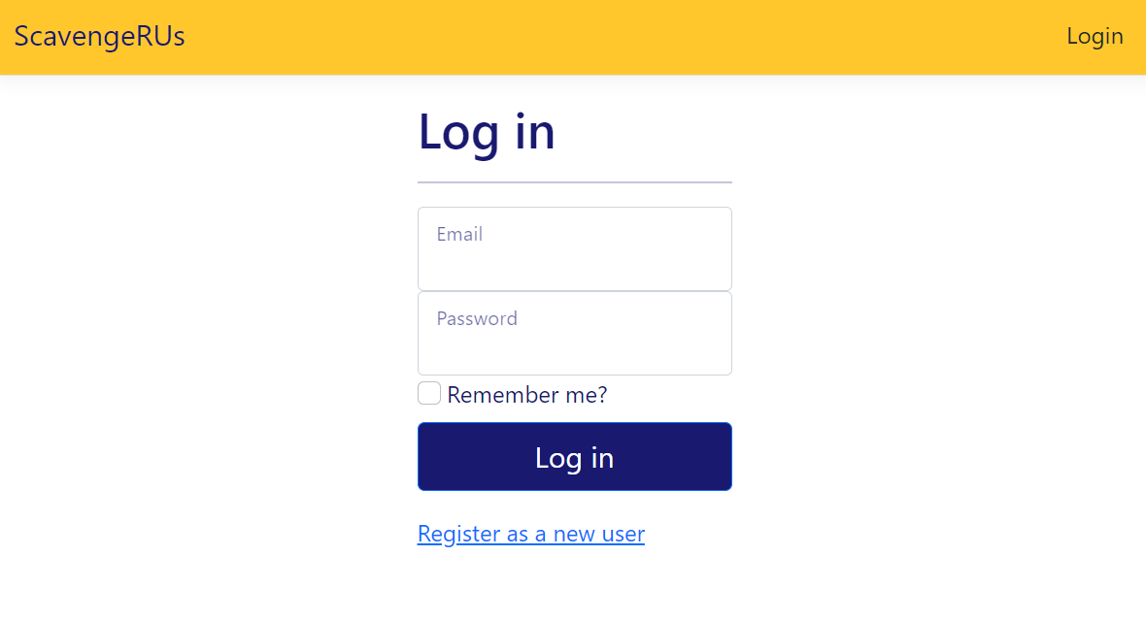

1. The admin of this project’s credentials are:
   1. Email: [waltonca@etsu.edu](mailto:waltonca@etsu.edu)
   2. Password: YMXH@9J!72kM6Em
2. Press the “Log in” button after you enter the credentials above. You should be taken back to the BucHunt landing page:

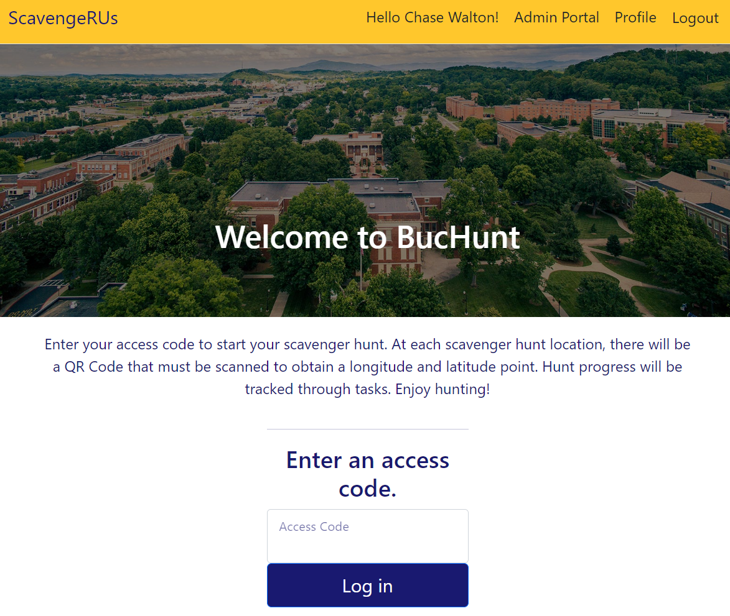



1. Click on “Admin Portal” (highlighted in red above). You should be taken to the screen below:

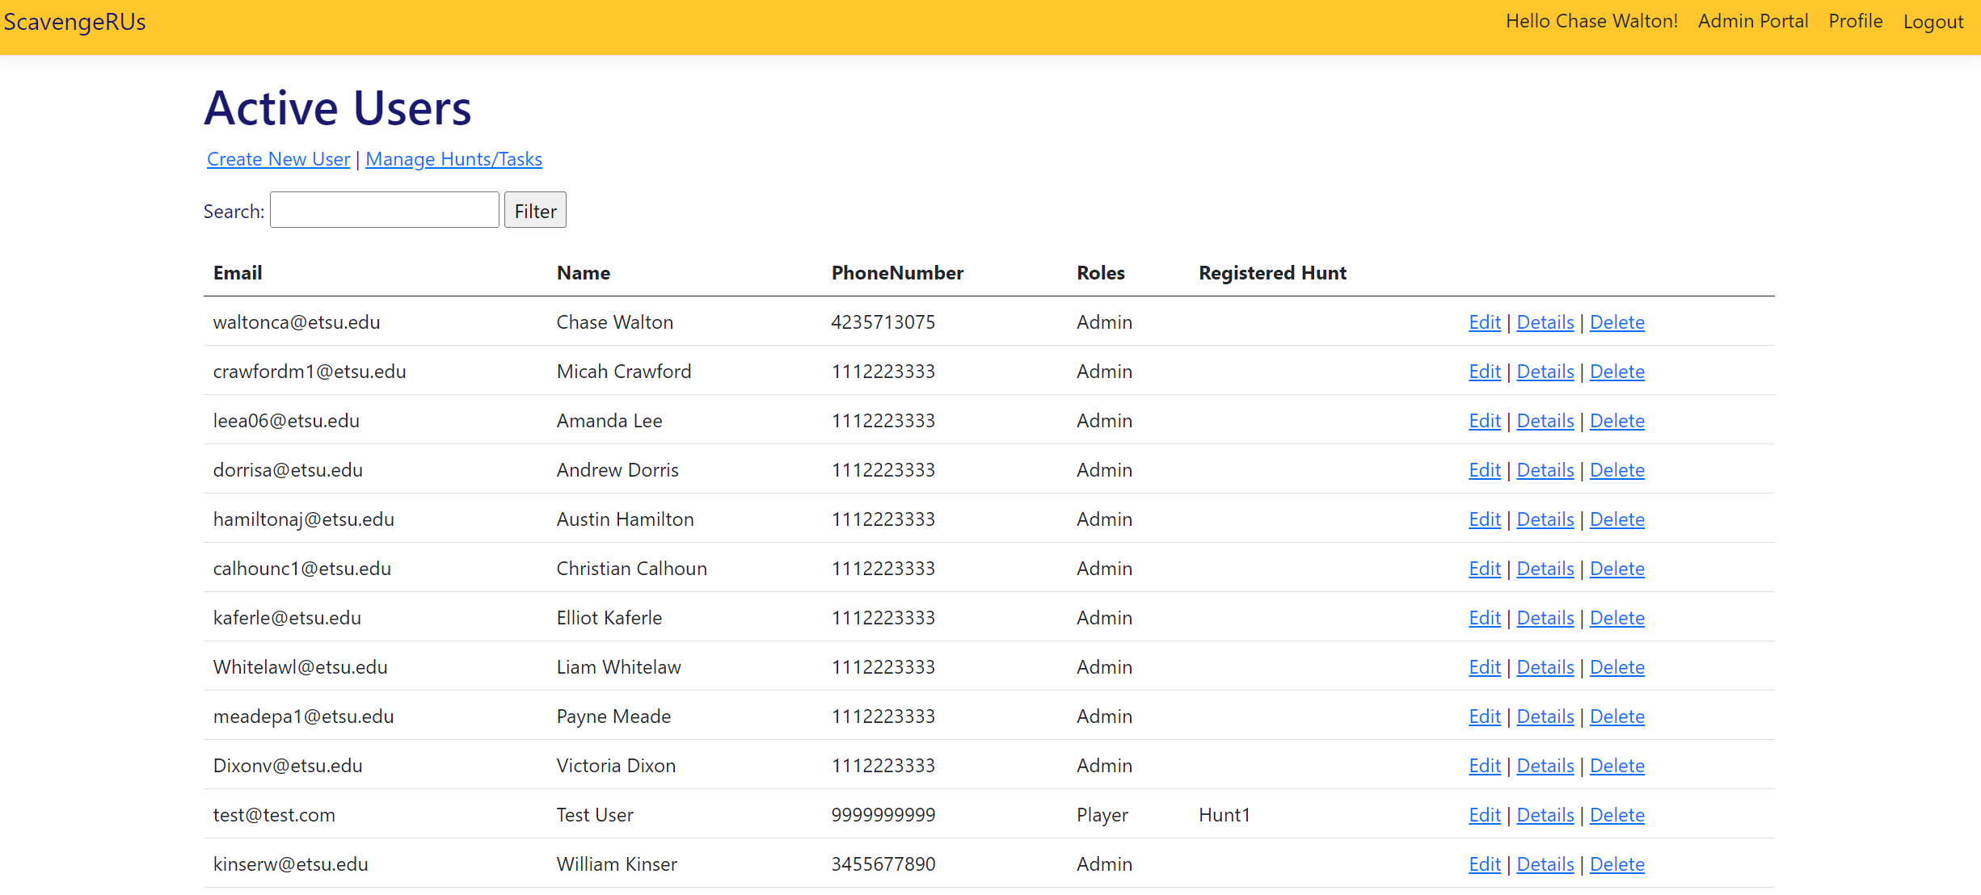

1. If you are wanting to create an **ADMIN, click Create New User**. However, don’t do this when adding a new user – there is a better way. If you want to create a **USER, click Manage Hunts/Tasks**

### Making an(other) Admin

1. Enter the Email, First Name, Last Name, and Phone Number of the person you want to add as an admin.
2. Select the “Admin” Role. By now, your website should look similar to this:

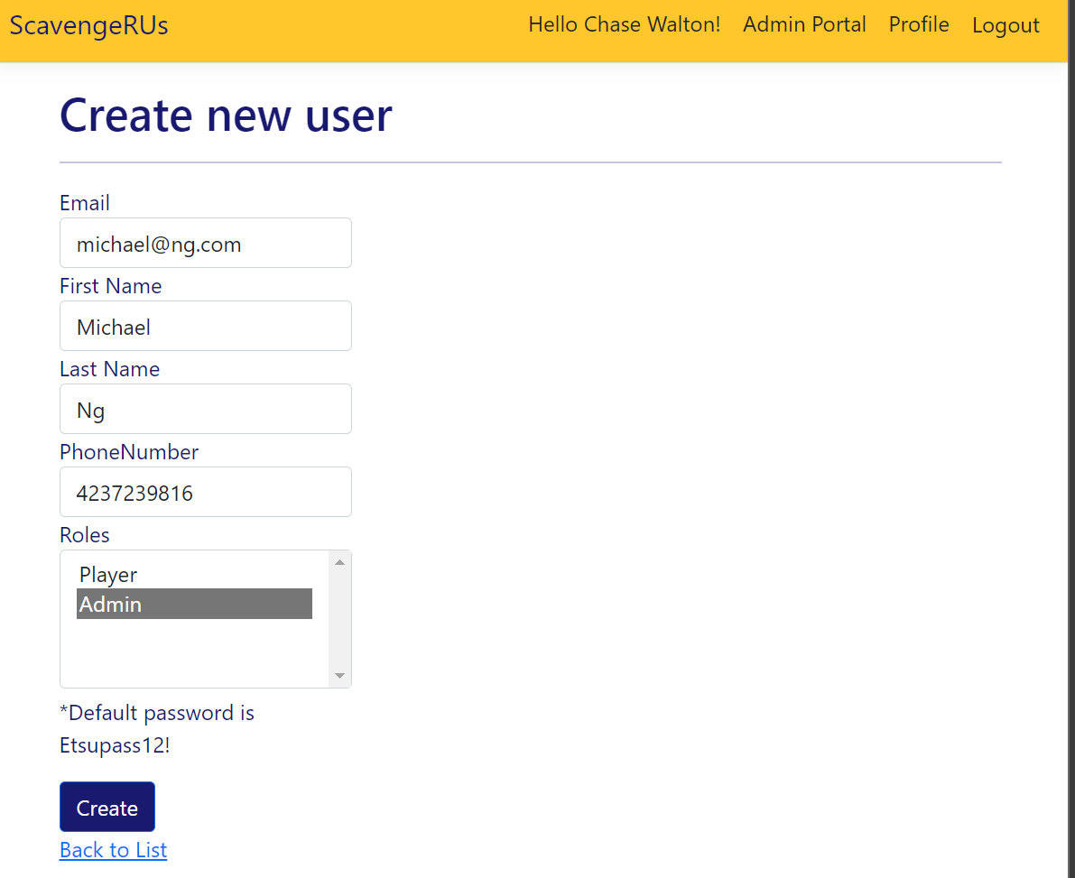

1. You will be taken to a details page. It looks like this:

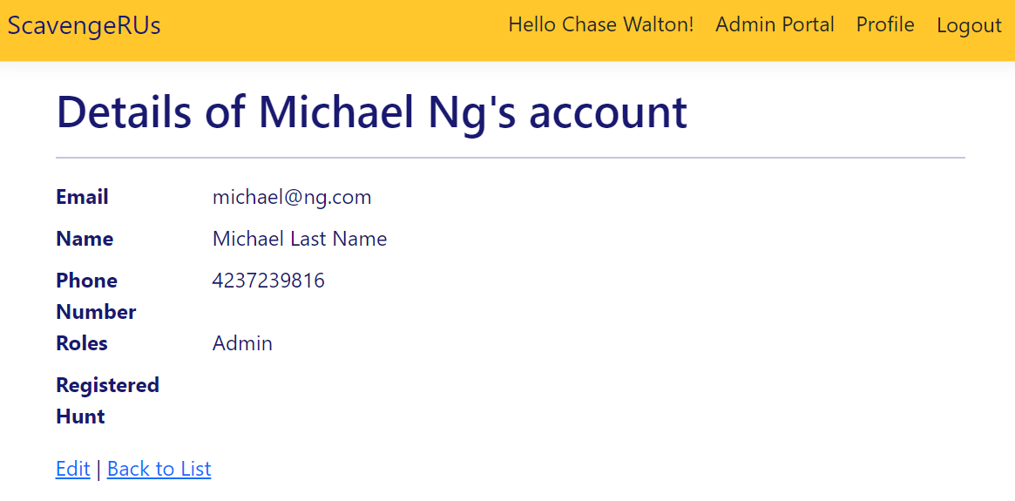



1. Remember the email for this admin! You will need it when you sign in.
2. To login as the admin you created, first, logout (top right).
3. Click “Login”
4. Put in the credentials of the admin you just created. Also, note that the default password is Etsupass12! Your screen should look something like this:

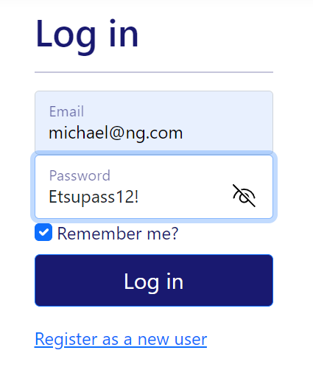

1. Hit “Log in”. You are now signed in as an admin!

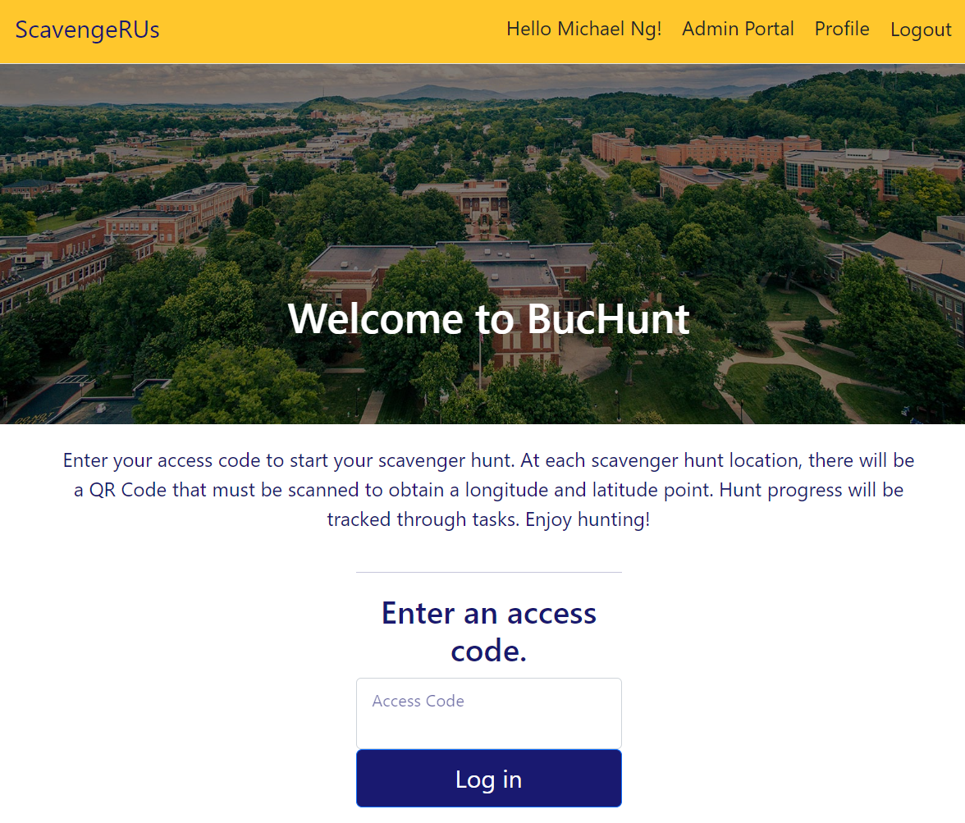



### Making Another User

1. From the Admin Portal, click on “Manage Hunts/Tasks”.

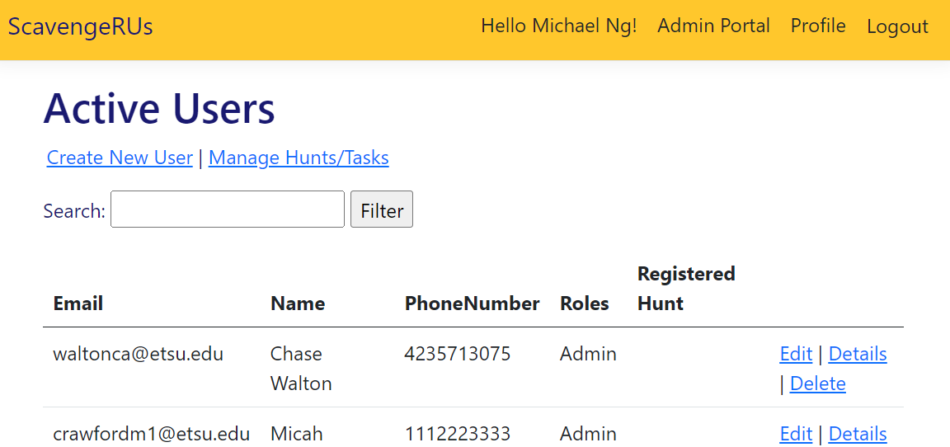



1. You should be taken to this webpage:

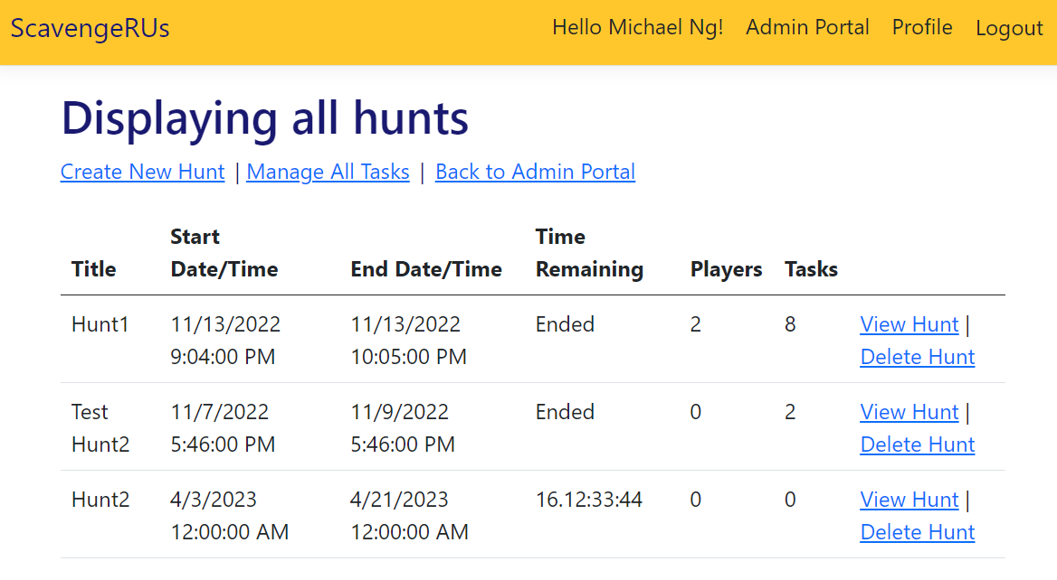



1. You can add new hunts through this webpage, but this guide will focus on users. Click on View Hunt for any of the hunts. (This example will use Hunt1). The result should look like this:

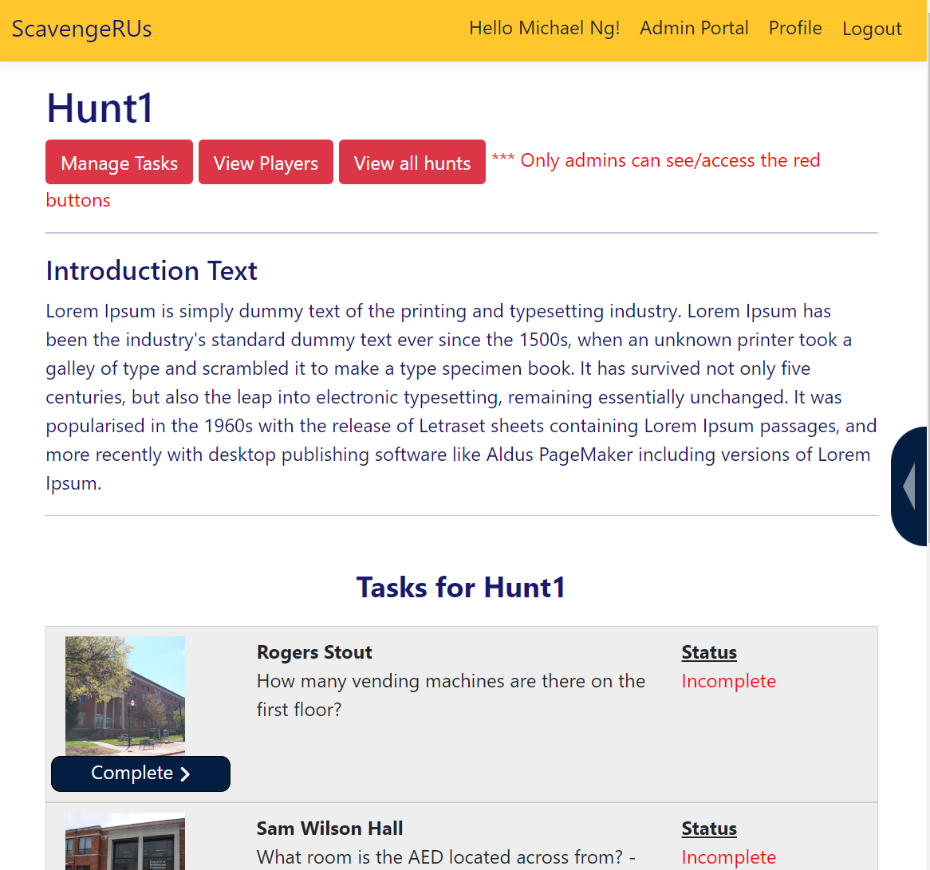

1. Click on “View Players”. You should see this screen:

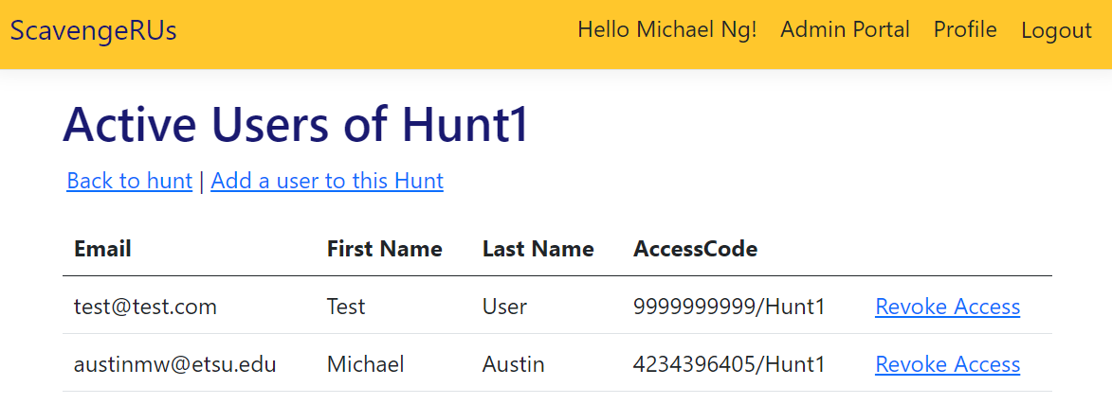



1. Click on “Add a user to this Hunt”. You should see this:

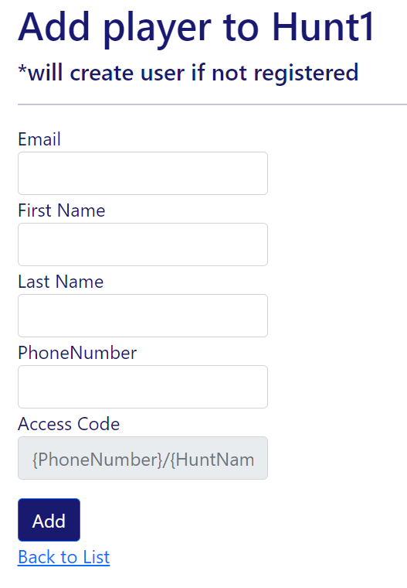

1. Add the user information to the hunt. Then click “Add”.

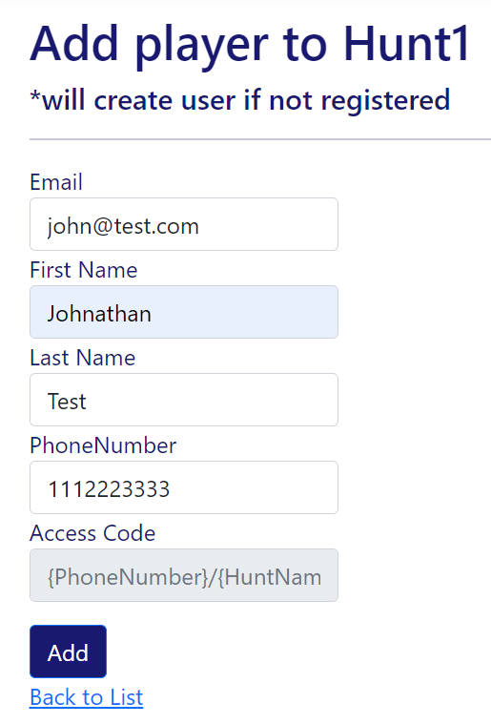

1. You should be taken back to the hunt screen. Go on “View Hunt” next to the hunt you were editing and click on “View Players”. Congratulations! You have added the user!

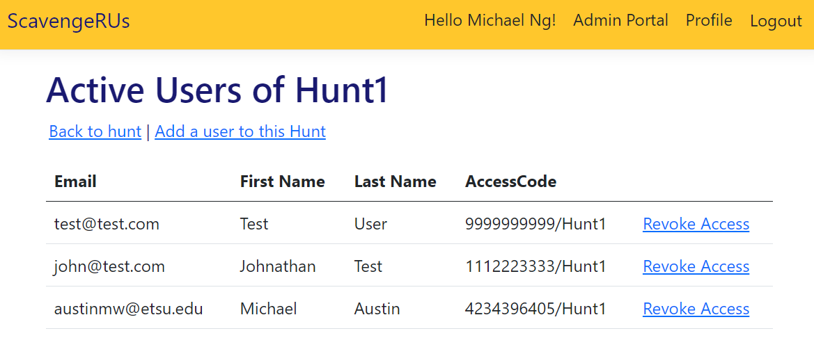



1. Next is signing in as the user to confirm that they can participate in the hunt. Remember the AccessCode of the user you just created! Click “Logout” once you’ve written down the AccessCode somewhere.
2. Type in the user’s access code in the box. Then click on the “Log in” button.

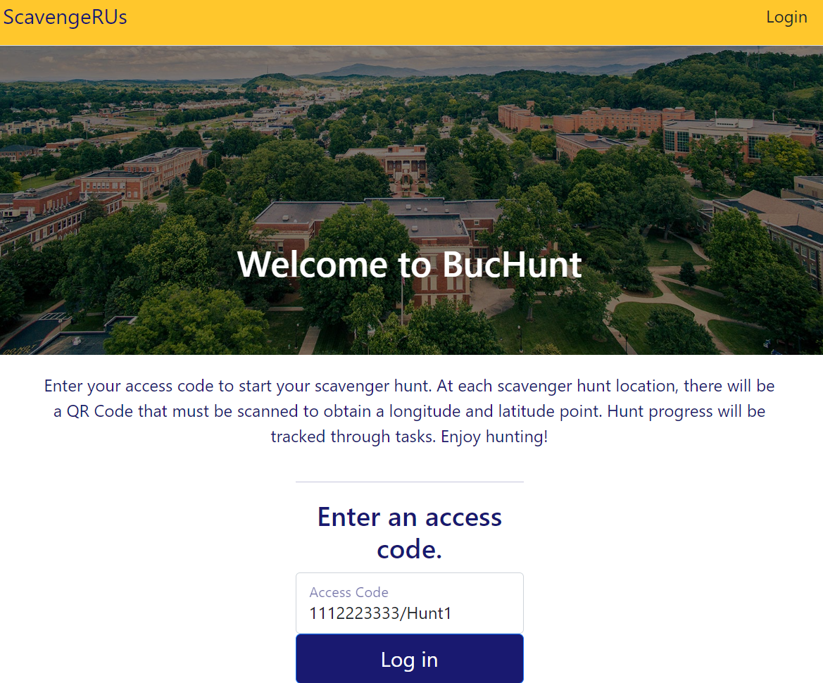

1. Hurray! We’ve logged in as the user!

